**Title of your Thesis**

**A subtitle if you wish**

by

Your Name

**ABSTRACT**

An abstract is a short description of 2-4 sentences summarizing the nature of your thesis project and what it’s about. For example, a five-minute 3D animation about a … who encounters a… and learns that… Please note that the formatting here is “Justify” whereas the rest of your paper will be formatted “Align Left”

**Title of your Thesis**

**A subtitle if you wish**

by

Your Name

© 2009 Your Name

A thesis

Submitted in partial fulfillment

of the requirements for the degree of

Master of Fine Arts

(Department of Digital Arts)

School of Art and Design

Pratt Institute

Month 2009

**Title of your Thesis**

**A subtitle if you wish**

by

Your Name

Received and approved:

___________________________________________ Date _______________

Thesis Advisor – Liubo Borissov

___________________________________________ Date ______________

Chair – Peter Patchen

**ACKNOWLEDGEMENTS**

This section is where you thank individuals or organizations if you wish to do so. Acknowledgements are optional and so is this section.

Start Roman Numerals on this page….

**LIST OF ILLUSTRATIONS**

Figure

1. xxxxxxxxxxxxxxxxxxxxxx __________________________________13

2. xxxxxxxxxxxxxxxxxxxxxx __________________________________22

3. xxxxxxxxxxxxxxxxxxxxxx __________________________________25

etc.

….continue with the Roman numerals

**TABLE OF CONTENTS**

ACKNOWLEDGEMENTS ------------------------------------------------------------------ iv

LIST OF ILLUSTRATIONS ----------------------------------------------------------------- v

CHAPTER

1. INTRODUCTION ----------------------------------------------------------------- 1

2. INFLUENCES ---------------------------------------------------------------------- 3

Subsection

Subsection

3. ISSUES OF CONTENT --------------------------------------------------------- 8

Subsection

Subsection

4. AESTHETIC ISSUES ------------------------------------------------------------ 19

Subsection

Subsection

Subsection

5. TECHNICAL ISSUES ------------------------------------------------------------ 23

Subsection

Sub-subsection

Sub-subsection

Subsection

6. CONCLUSION --------------------------------------------------------------------- 25

6. BIBLIOGRAPHY ------------------------------------------------------------------ 26

REFERENCE LIST ---------------------------------------------------------------------------- 26

DVD ------------------------------------------------------------------------------------------------ pocket

**CHAPTER 1**

INTRODUCTION

In this section you should write about any preliminary thoughts or ideas you want to convey before getting into the actual discussion of your paper. This section allows you to set the tone and to “prime” the reader. For example, you can begin with a sentence sch as… “What led me to my interest in 3D animation….” Or, “Rapidly changing technology informs the way art is practiced today….”

Notice that the text is double-spaced and “aligned left,” not “justified.” Also, notice that the chapter pages have a 2” margin on top; other text pages have a 1” margin on top. The margin on the left is 1.5”, on the bottom and the right side of the page it is 1”. From this page on, write page numbers in Arabic numerals (1, 2, 3, …)

Notice also that the first line of the first paragraph on this page is not “indented,” while the second one is… the first lines of all following paragraphs should also start with an indentation. When you start a new chapter, the first line is again not indented.

There are no extra spaces between paragraphs. When you first mention an author you are referencing, cite first and last name; thereafter only cite the last name. Periods are followed by a single space (not two). Commas and periods go inside of end quotation marks: Marshall McLuhan said, “ The medium is the message**.”** If you cite the title of a movie, put the name in italics followed by the date it was released in parenthesis. Make sure to consult the *Guidelines for Graduate Thesis* document for details on formatting….

**CHAPTER 2**

INFLUENCES

Optional Subtitle

More text…. Note that you should be discussing your project as though the project is complete. All quotations over forty words are considered “long quotations.” What follows is an example of how to reference a long quotation. Notice that for a long quotation, you do not include quotation marks. Observe the formatting. Notice also that titles should be put in italics. Example: In *Zeros and Ones* Sadie Plant discusses the effects of modern communication devices and remarks,

There is always a point at which technologies geared towards regulation, containment, command, and control, can turn out to be feeding into the collapse of everything they once supported. All individuated notions of organized selves and unified lives are thrown into the question on a Net whose connectivities do not merely extend between people as subjects with individual faces, names, and identities. The terminology of computer mediated communication implies and increasing sense of distance and alienating isolation, and the corporate hype enthuses about a new sense of interpersonal interaction. [1]

Here is a sample of how you can reference a short quotation. In short quotations, quotation marks are included but there is no indent. Example: In this context, Lev Manovich states, “This ‘crisis’ of cinema's identity also affects the terms and the categories used to theorize cinema's past.”[2] Please note that anything you quote must be referenced at the end of your paper in the *References* section.

Here is an example of how you can include some illustrations. It makes sense to place the illustration close to the text making reference to it. Notice that the figure number is referenced from within the text:

In style the resulting images initially related most closely to the work of Paul Klee who valued the "primitive," and especially the art of children (Figure 2).

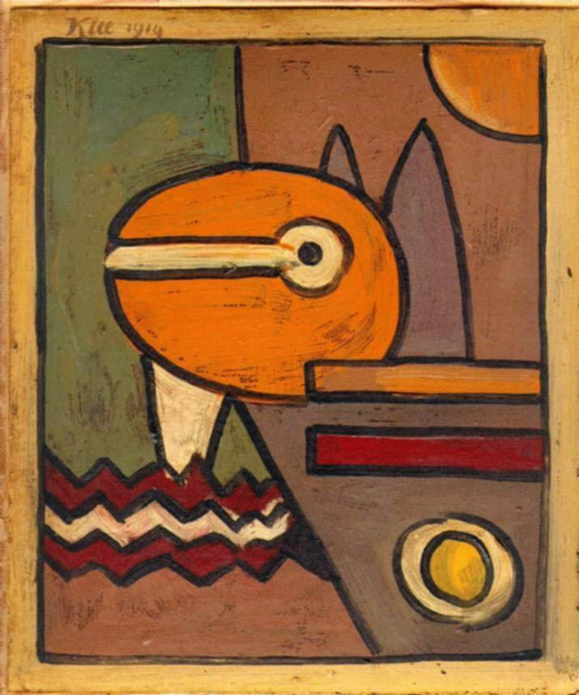

Fig. 2. Paul Klee

More text.

**CONCLUSION**

Here is where you summarize your findings and draw conclusions. For example, you can speak about the experience of creating the project and in which ways it succeeds. You can also explain to the reader what you have learned in the process of creating your theses and how the completion of your project will inform your future art work.

1. **REFERENCES**

   Sadie Plant. *Zeroes and Ones: Digital Women and the New Technoculture* (New York: Double Day, 1997), 35.
2. Lev Manovich, *The Language of New Media* (Cambridge: MIT Press, 2001), 55.

   *Note that there are many different styles of citation. In this sample paper, I have used MLA style because I have a lot of practice with it and find it easy… The Guidelines for Graduate Thesis document lists several styles that you may use, including the popular Harvard style. Pick a style early on and immediately begin writing down all of your endnotes and references in the proper format. Make sure to take careful note of the titles, year and place of publication, publisher, and page numbers of sources cited.*

   **BIBLIOGRAPHY**